Similarity Pre-Task Problems

Using concepts of similar triangles & the side-splitter theorem that we learned, solve the following modeling mapping problems.

1. Find the length across the lake (BC).
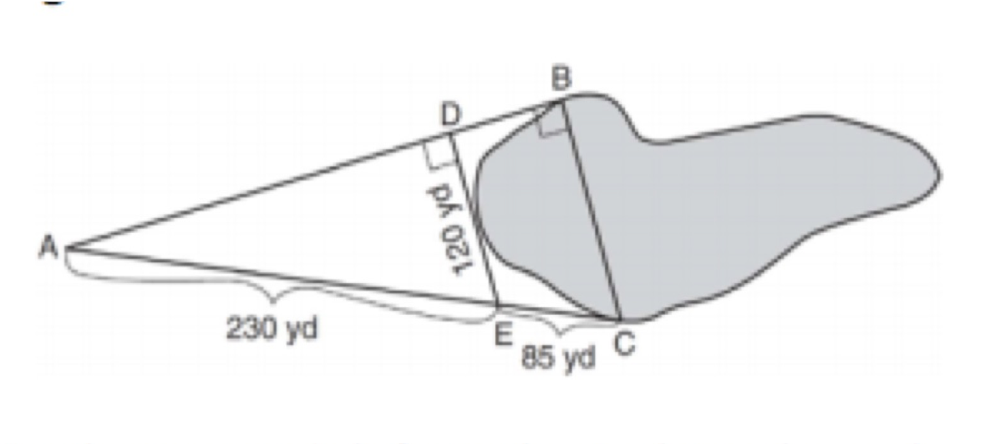

2.

